Q.1 | a. | Is there a different definition of software Architecture that are you familiar with?If so, think about the way in which this definition supports acid test of an architecture: Does it abstract information away from the system and yet provide enough information to be a basis for decision making, artifact and discipline? | (6)
 | Answer | Yes. There are different definition of software architecture. Software architecture refers to the fundamental structures of a software system and the discipline of creating such structures and systems. Each structure comprises software elements, relations among them, and properties of both elements and relations.  Software architecture is the defining and structuring of a solution that meets technical and operational requirements. Software architecture optimizes attributes involving a series of decisions, such as security, performance and manageability. These decisions ultimately impact application quality, maintenance, performance and overall success.  Software Architecture = { Elements, form, Rationale }  Types of Elements  Processing Elements  Data Elements  Connecting Elements  A software architecture is defined by a configuration of architectural elements--components, connectors, and data--constrained in their relationships in order to achieve a desired set of architectural properties  [Each definition will get 1 marks for correct answer.]  Software architecture as a discipline aims at creating techniques to describe existing software systems, prescribing how to build a new software system and evaluate the configuration of the software systems.  Software architecture as an artifact : A set of models describing the structure and behaviour of software system is referred to as software architecture.  Software Architecture is a set of artifacts (Principles, guidelines,policies,models, standard and processes) and the relationships between these artifacts, that guide the selection , creation and implementation of solutions aligned with business goals.  Software system is an artifact. It is the result of software design activity.  Software architecture as a decision making : It is a process of design decision made during software system development along with rationalizing the decision taken.  Each correct definition : 1 Marks and Example or diagrams : 1 Marks  Any suitable diagram which explain the concept of software architecture as a discipline , artifact and decision making.  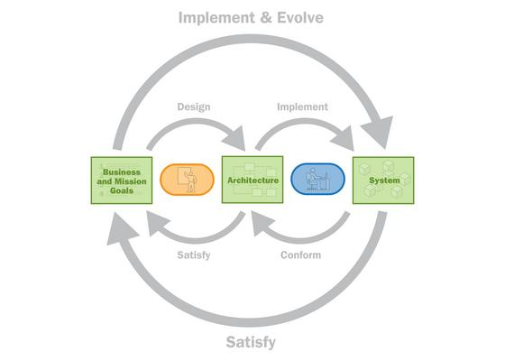
 | b. | Software Architecture is often compared to building architecture.What are the strong point of this comparison? | (4)
 | Answer | Both software and building architects work with clients to develop plans for a specific job. A software architect may design a simple database for tracking sales or a complete integrated system for a major company to run its operations. Likewise, a building architect may create plans for a single room structure to display artwork or a complete high-rise building to house multiple businesses and organizations. In both cases, the architect is responsible for designing the appropriate structure which will meet the client's needs within a specified budget.  Both software and building architects must test the integrity of the structures they build and verify that their structures conform to the drafted outline presented to the client. Though they share the same fundamental responsibilities as architects, the mediums in which they work are completely different, as are the tools they utilize to accomplish the task. Software architects are computer science experts who work with IT teams, while building architects are construction experts who work with engineering and construction teams.  Job responsibilities of a software architect include:  - Gathering information on computer limitations for data processing  - Consulting with computer engineers to determine hardware capabilities  - Reporting on design, implementation and functional capacity of new software  - Determining power needs and cost of project  Job responsibilities of a building architect include:  - Completing a feasibility study prior to construction  - Preparing scale models of building project  - Verifying engineering components of building project  - Estimating cost and construction time  - Negotiating contracts with client and contractors  We can summarize this answer as  Building architecture is characterized by  i)Building architects work with customers by means of a number of different views in which some particular aspects of a building is emphasized.  ii)Each building follows an architectural style.  iii)Example: Apartments ,row house, indepemdent bunglow 1 HK 2BHK [1 Mark]  iv)There is relationship between architectural style and enginnering.  Similarly architectural styles and material of construction are related. [Each point will get 1 mark each total = 4 marks. If there will be any creative diagram then it will also constitute marks if student falling short to get marks in this question ]
Q.2 | a. | If it is true that two different architects in different organizations will produce different architectures for same technical requirements for a system, how can one determine if either one of them is the right one? | (6)
 | Answer | A technical requirement pertains to the technical aspects that your system must fulfill, such as performance-related issues, reliability issues, and availability issues. These types of requirements are often called quality of service (QoS) requirements, service-level requirements or non-functional requirements (I don't like that term as it makes them sound like requirements that won't work). Examples of technical requirements are presented in below.  As you can see, technical requirements are summarized in a similar manner as Business Rules: they have a name and a unique identifier (my convention is to use the format TR#, where TR stands for technical requirement).  You document technical requirements in the same manner as business rules, including a description, an example, a source, references to related technical requirements, and a revision history.  Figure 1. Technical requirements (summary form).  - TR34 The system shall be available 99.99% of the time for any 24-hour period.  - TR78 A seminar search will occur within less than three seconds 95 percent of the time.  - TR79 A seminar search will occur within no more than ten seconds 99 percent of the time.  For example, when asked why your application must be written in Java, the reply was it has to run on the Internet. When asked why it must run on the Internet, the reply was your organization wants to take orders for its products and services on the Internet. The real requirement is to sell things to consumers at their convenience; one technical solution to this need (and a good one) is to write that component in Java that can be accessed via the Internet. A big difference exists between having to write the entire application in Java and having to support the sales of some products and services to consumers over the Internet.  A business rule defines or constrains one aspect of your business that is intended to assert business structure or influence the behavior of your business. Business rules often focus on access control issues, for example, professors are allowed to input and modify the marks of the students taking the seminars they instruct, but not the marks of students in other seminars. Business rules may also pertain to business calculations, for example, how to convert a percentage mark (for example, 91 percent) that a student receives in a seminar into a letter grade (for example, A-). Some business rules focus on the policies of your organization, perhaps the university policy is to expel for one year anyone who fails more than two courses in the same semester.  Figure 1. Some sample business rules (summary form).  - BR123 Tenured professors may administer student grades.  - BR124 Teaching assistants who have been granted authority by a tenured professor may administer student grades.  - BR177 Table to convert between numeric grades and letter grades.  - BR245 All master's degree programs must include the development of a thesis  On the basis of three point this answer the assess  1) Understanding of concept of technical requirements. [2 Marks]  2) illustrate your answer with the correct Examples and diagrams. [2 Marks]  3)On same techincal requirement, How will have architect 1 and architect 2 different opinions and scanrios? [2 Marks]  If you still not undersood the answer then refer the following link you will get the idea.  https://pubs.opengroup.org/architecture/togaf8-doc/arch/chap31.html
 | b. | What are different benefits of Software Architecture? | (4)
 | Answer | i)Architecture as a framework for satisfying requirements. [ 1 Mark]  ii)Architecture as a technical basis for design and magerial basis for post estimation and process management.[1 mark]  iii)Architecture is useful for effective basis for reuse in software design as well as architecture.[1 mark]  iv) Architecture can be benefits as a dependency and consistency analysis.[1 mark]
Q.3 | a. | Explain the purpose of different architectural views included in P. Kruchten’s 4+1 view model. | (6)
 | Answer | Diagrams [ 2 Marks]  Each view with valid 4 point will consist of 1 Marks each.  4 points are  i) Functionality of the view  ii) Stakeholder involved in that view  iii) UML Diagrams involved in that view.
 | b. | Define following terms I) Architecture viewpoint ii)Stakeholder | (4)
 | Answer | A view will comprise selected parts of one or more models, chosen so as to demonstrate to a particular stakeholder or group of stakeholders that their concerns are being adequately addressed in the design of the system architecture. A viewpoint defines the perspective from which a view is taken. ... A view is what you see.  An architectural view is a representation of one or more aspects of an architecture that illustrates how the architecture addresses the concerns held by one or more of its stakeholders. A viewpoint is a collection of patterns, templates, and conventions for constructing one type of view  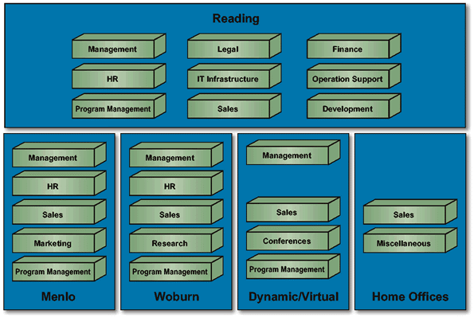  Architetcural viewpoint: Definition : Correct [2 Marks ]  Any two example [ 2 Marks]  ii)Stakeholder : Definition [ 2 Marks] Example and role or Diagrams: [ 2 Marks]  people or things (e.g. other systems) that have requirements or expectations about a system.  The stakeholders have different needs and interests, and therefore pose different requirements. In order to be able to take these requirements into consideration when building an architecture, the architect must identify all stakeholders, find out what their needs and requirements are, analyze the requirements together with the stakeholders, and prove to the stakeholders that the architecture he builds meets their demands.  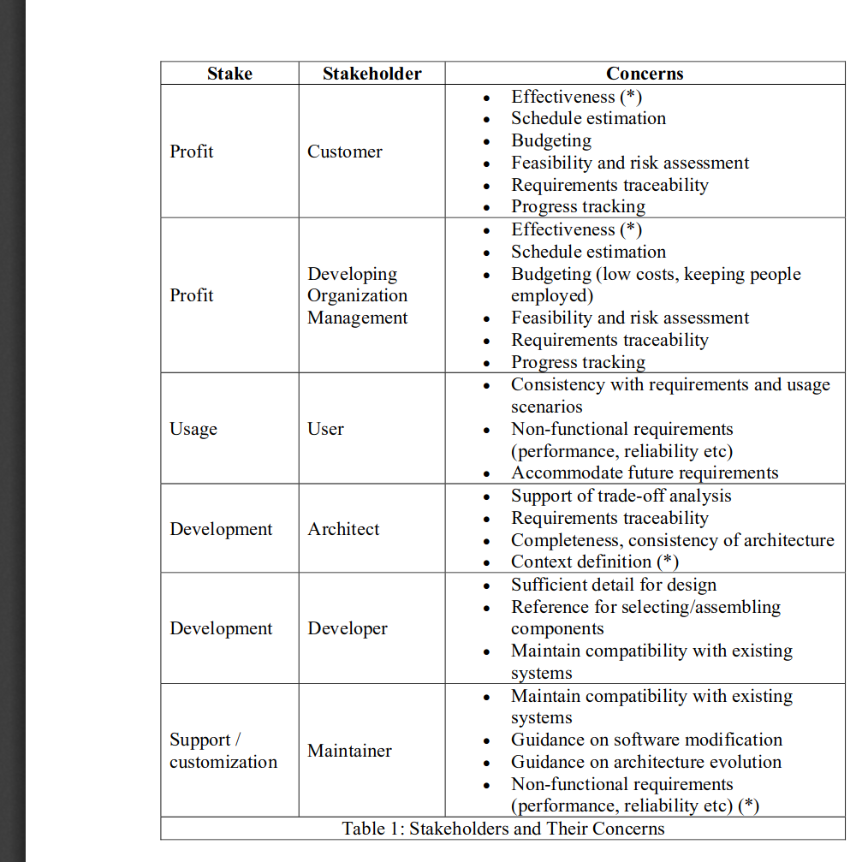
Q.4 | a. | Define software architecture and quality attributes are related to each other by giving various architectural techniques adopted to achieve security. | (6)
 | Answer | Computer systems are used in many critical applications where a failure can have serious consequences (loss of lives or property). Developing systematic ways to relate the software quality attributes of a system to the system’s architecture provides a sound basis for making objective decisions about design trade-offs and enables engineers to make reasonably accurate predictions about a system’s attributes that are free from bias and hidden assumptions. The ultimate goal is the ability to quantitatively evaluate and trade off multiple software quality attributes to arrive at a better overall system. The purpose of this report is to take a small step in the direction of developing a unifying approach for reasoning about multiple software quality attributes. In this report, we define software quality, introduce a generic taxonomy of attributes, discuss the connections between the attributes, and discuss future work leading to an attribute-based methodology for evaluating software architectures.  Introduction:  Computer systems are used in many critical applications where a failure can have serious con- sequences (loss of lives or property). Critical applications have the following characteristics:  - The applications have long life cycles (decades rather than years) and require evolutionary upgrades.  - The applications require continuous or nearly non-stop operation.  - The applications require interaction with hardware devices.  - The applications assign paramount importance to quality attributes such as timeliness, reliability, safety, interoperability, etc.  Developing systematic ways to relate the software quality attributes of a system to the system’s architecture provides a sound basis for making objective decisions about design trade- offs and enables engineers to make reasonably accurate predictions about a system’s at- tributes that are free from bias and hidden assumptions. The ultimate goal is the ability to quantitatively evaluate and trade off multiple software quality attributes to arrive at a better overall system.  Software Quality Attributes:  Developers of critical systems are responsible for identifying the requirements of the application, developing software that implements the requirements, and for allocating appropriate resources (processors and communication networks). It is not enough to merely satisfy functional requirements. Critical systems in general must satisfy security, safety, dependability, performance, and other, similar requirements as well. Software quality is the degree to which software possesses a desired combination of attributes (e.g., reliability, interoperability) [IEEE 1061].  How Various Communities Have Addressed Quality Attributes:  There are different schools/opinions/traditions concerning the properties of critical systems and the best methods to develop them:  - Performance — from the tradition of hard real-time systems and capacity planning  - Dependability— from the tradition of ultra-reliable, fault-tolerant systems  - Security — from the traditions of the government, banking and academic communities  - Safety — from the tradition of hazard analysis and system safety engineering  Systems often fail to meet user needs (i.e., lack quality) when designers narrowly focus on meeting some requirements without considering the impact on other requirements or by taking them into account too late in the development process.  Software Quality Attribute Trade-offs:  Designers need to analyze trade-offs between multiple conflicting attributes to satisfy user requirements. The ultimate goal is the ability to quantitatively evaluate and trade off multiple quality attributes to arrive at a better overall system. We should not look for a single, universal metric, but rather for quantification of individual attributes and for trade-off between these different metrics, starting with a description of the software architecture.  Software Architecture Design Non-Functional Requirements:  - Introduction (Functional Requirements):  Non-functional requirements are different from functional requirements in many ways.  - Functional Requirements:  - Describe what a system should do.  - Mostly come from the customer.  - Can be described by a Use Case model and set of formal “shall” statements.  - Non-Functional Requirements:  - Are not related to individual use cases, but rather to system-wide attributes like performance.  - Can be complete show-stoppers if not met. # Often conflict with each other, requiring trade-offs.  - Are more architecture-dependent than functional requirements.  - Are often determined by the architect and stakeholders within the organisation.  - Can be described in terms of standard Quality Attributes.  Quality Attributes:  Usually, business considerations determine the qualities that must be accommodated in a system architecture.  Too often, functionality overrides maintainability, portability, scalability, and other factors determining the long-term success of a project.  Functionality and quality attributes are orthogonal, since a given functionality can be achieved by many different architectures.  Quality requirements depend on the system architecture more than on the functional requirements.  There are three main categories of quality attributes:  - System Qualities: availability, modifiability, performance, security, testability, usability, others.  - Business Qualities: time to market, cost and benefit, product lifetime, target market, roll-out schedule, integration, others.  - Architectural Qualities: conceptual integrity, correctness and completeness.  [Introduction 1 Marks not necessary to write all the description which is mentioned in the solution]  Security tactics  Tactics for achieving security can be divided into those concerned with resisting attacks, those concerned with detecting attacks, and those concerned with recovering from attacks. All three categories are important. Using a familiar analogy, putting a lock on your door is a form of resisting an attack, having a motion sensor inside of your house is a form of detecting an attack, and having insurance is a form of recovering from an attack. figures shows the goals of the security tactics.  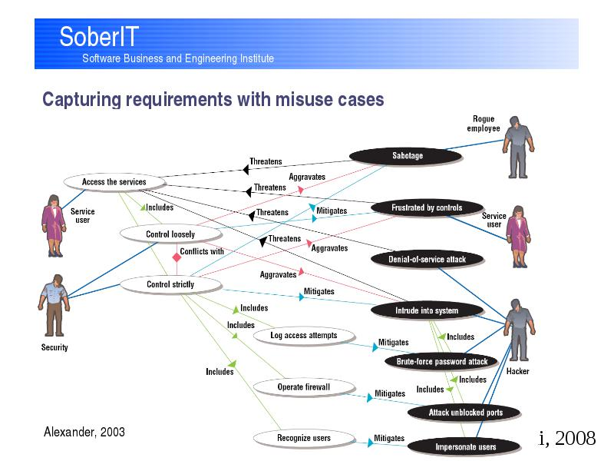  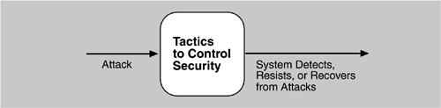  [Diagrams 1 Marks]  Security characterization consist of Nonrepudiation, Confidentiality , Integrity and assurance as goals.  Authenticate user : Authentication is ensuring that a user or remote computer is actually who is purports to be. Passwords, one-time passwords, digital certificates , and biometrics identifications provide authentication.  Auhorize users : Authorization is ensuring that an authenticate user has the rights to access and modify either data or services. This is usually managed by providing some access control patterns within a system. Access control can be user by user class. Classes of users can be defined by user groups, by user roles or bby lists of individuals.  Maintain data confidentiality : Data should be protected from unauthorixed access.Confidentiality is usually achieved by applying some form of encryption to data and to communication  Description [  Diagrams [ 2 Marks]  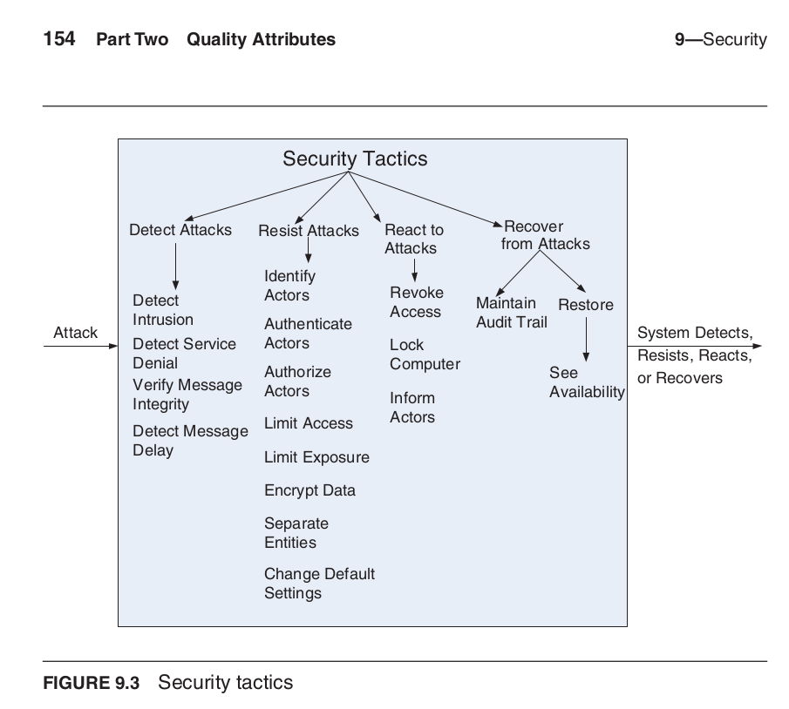
 | b. | Define the following quality attribute with example 1)Reliability ii) Modifiability | (4)
 | Answer | Diagrams [ 1 Mark ] and Explanation [ 1 Mark]  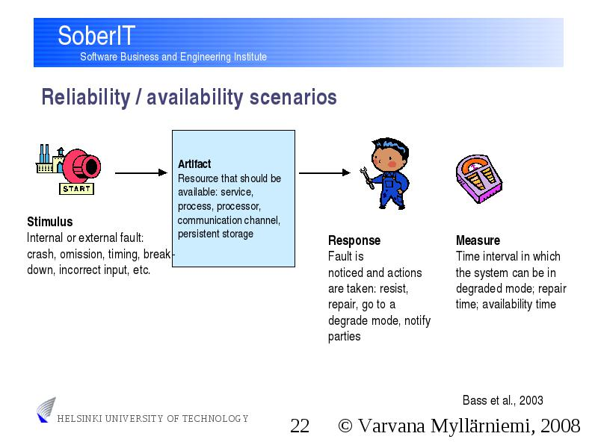  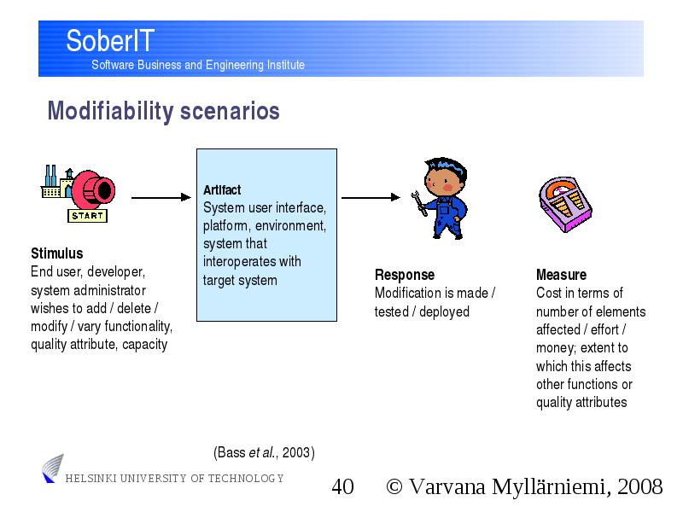  Reliability Quality attributes  Modifiability :

